



**Financial Analysis Statement**

**Financial Analysis B9AC106_1819_TMD2**

**Lecturer: Enda Murphy**

**Student Number: 10380700**

**Word Count: 2836**

Index

Introduction: 5

1. Profitability Ratio 6

1.1 Gross Margin 6

1.2 Operating Profit 6

1.3 ROCE (Return on Capital Employed) 6

1.4 ROE (Return on Equity) 6

1.5 Capital Turnover 7

Comparison of Competitor on Profitability Ratio 7

2. Liquidity Ratio 8

2.1 Current Ratio and Acid Test Ratio 8

Comparison of Competitor on Liquidity Ratio 9

3. Efficiency Ratio 10

Comparison of Competitor on Efficiency Ratio 10

4 Gearing RATIOS 12

Comparison of Competitor on Gearing Ratio 12

5 Investment Ratios 13

Comparison of Competitor on EPS and P/E Ratio 14

6 Initiatives for future probabilities 15

7 Market Verdict and future prospects 16

7.1 Future Prospects 16

7.2 P/E RATIO analysis 17

7.3 Market to Book Ratio 18

Bibliography 19

**List of Table**

Table 1summery of Tristel PLC financial analysis (2014-2018) 6

Table 2 gross profit percentage of Tristel vs Abcam 7

Table 3 Comparison of operating profit of Tristel PLC and Abcam PLC 8

Table 4 Current test ratio and Acid test ratio of Tristel PLC 8

Table 5 Acid test ratio 9

Table 6 Current Ratio 9

Table 7 Net receivable vs Net payable days 10

Table 8 Net Receivable of Tristel vs Abcam 10

Table 9 Net payables of Tristel vs Abcam 11

Table 10 Inventory days of Tristel vs Abcam 11

Table 11 Gearing and Debt to Equity Ratio 12

Table 12 Gearing Ratio Tristel vs Abcam 12

Table 13 Debt to Equity ratio Tristel Vs Abcam 12

Table 14 D/E Comparison according to industrial Norms 13

Table 15 EPS vs P/E of Tristel PLC 14

Table 16 P/E ratio of Tristel vs Abcam 14

Table 17 EPS of Tristel vs Abcam 15

Table 18 P/E ratio 17

Table 19 analyst growth expectation(st, simply wall st, 2019) 18

**List of Images**

Figure 1 abcam plc(abcam, 2019) 7

Figure 2 Tristel PLC Past and future earnings 28 March 2019. (AIM) 16

Figure 3 Analyst Growth expectations 17



(Insider Media Limited, 2019)

Introduction: **-**

*“We have chemistry.” “Why disinfect when you can Tristel?”*

(Tristel, 2019)

Tristel Plc is one of a few businesses worldwide listed on the AIM

(Alternative Investment Market) provider of infection prevention

products and contamination control in human, animal healthcare

and pharmaceutical as well as personal care manufacturing plants

and industrial water systems founded in 1993. A trademarked chlorine

dioxide formulation was synthesized by the founding shareholders,

which could be used to disinfect flexible endoscopes instead of using

glutaraldehyde. The company was listed on the London Stock Exchange AIM

market in 2005 and it is an ISO 9001:2015 and BE EN 13485:2016 certified

manufacturer of disinfectants. The company has its peripherals in countries

such as Poland, Russia, Switzerland, Germany, Hong-Kong, China, Japan, USA,

Australia, New Zealand and sales plants in more than 30 other countries. (*ibid*)

# 1. Profitability Ratio

The consolidated balance sheet gives the exact details about the company’s annual fundamentals. The consolidated balance sheet of Tristel PLC hence shows its level of dividend growth, profit and revenue rate in the market as they are specialised provider of infection prevention human and animal healthcare as well as contamination control in industry.

The financial fluctuation in the business market worldwide is discussed by the ratios as follows.

|  |  |
| --- | --- |
| Tristel PLC | 2014 2015 2016 2017 2018 |
| Gross Margin % | 69.81 69.53 73.40 77.32 77.32 |
| Operating Profit % | 13.50 16.57 15.01 19.25 17.91 |
| ROCE % | 14.80 17.73 17.01 24.03 21.36 |
| ROE % | 10.53 15.64 14.05 21.27 17.16 |
| Capital Turnover | 1.10 1.07 1.13 1.25 1.19 |

Table summery of Tristel PLC financial analysis (2014-2018)

## 1.1 Gross Margin

Gross profit margin has rapidly increased from 69.81% 2016 to 77.32% in 2018 due to the growth of revenue as well as the profitable overseas operations. (Tristel PLC, 2016) Due to overseas sales growth rate, the overall revenue of the company significantly increased. Hence, it resulted into the increase in gross margin from year 2016 till 2018. (*ibid*)

## 1.2 Operating Profit

The operating profit increased from 13.5% 2014 to 19.25% 2017 and the ratio slightly decreased in 2018 (17.91%). Tristel generating high revenue because of their products worldwide as they achieved 25 overseas regulatory body approvals in 7 countries during this year. Tristel acquired the business of Australian distributors which was the main factor behind the rapid growth of operating profit and gross margin. (Tristel PLC, 2017)

## 1.3 ROCE (Return on Capital Employed)

The ratio shows that the company’s profitability and its efficiency with the help of capital used. ROCE calculates the total liabilities and the total equity also. As the ROCE of the Tristel PLC is improving, which means the company is doing a great job of deploying its capital. Here in this case the ROCE ratio is rapidly increasing from 2014. In the year 2014 the recorded percentage was 14.80%, on the other hand in 2018 this count has increased to 21.36%.

## 1.4 ROE (Return on Equity)

The ratio ROE calculates the net sales by the shareholders equity. The graph of ROE increased from 10.53% in 2014 to 21.27% in 2017 and this is because of the previous discussion of overseas investment as well as positive profit contribution by acquisition on Australia since few years. Tristel invested more for the future business plans of entering into the North American market was also the key factor for increase in ROE during these years. (Tristel PLC, 2017)

## 1.5 Capital Turnover

Capital turnover measures the efficiency of company’s working capital to assist a level of sales. Secondly, it gives the correlation of funds raised for companies work or operations and the net income generated by organization. Here in graph, consistent increase in the capital turnover from 1.10 in 2014 to 1.25 in 2017 and slightly decreased to 1.19 in 2018 is observed because of the effective level of sales worldwide. (WILL KENTON, 2019)

Accessed 20th March 2019.

## Comparison of Competitor on Profitability Ratio

Abcam PLC is one of the competitors of the Tristel PLC in the health care market worldwide. Abcam is the leading provider of life science research tools and high-quality reagents in the critical biological pathway. (Abcam PLC, 2019) However, the gross margin of the Tristel PLC is higher than the Abcam PLC as per the records of last five years.

Table gross profit percentage of Tristel vs Abcam

Here, initially the gross margin of Abcam was very high due to their product service worldwide in around 130+ countries. The reason behind the low rate of gross margin is increase in the cost of sales of Abcam products, even though the revenue goes on increasing the gross margin is lower than the Tristel PLC. (Abcam PLC, 2019)



Figure abcam plc (abcam, 2019)

Table Comparison of operating profit of Tristel PLC and Abcam PLC

While the comparison of operating profit, the Abcam plc is showing a great performance during past five years as the ratio itself is self-explanatory.

# 2. Liquidity Ratio

Liquidity ratio is the ratio which is used to calculate the company’s ability to pay its short-term liabilities with the help of quick assets. (Hill, 2019)

## 2.1 Current Ratio and Acid Test Ratio

|  |  |
| --- | --- |
| Tristel PLC | 2014 2015 2016 2017 2018 |
| Current Ratio | 2.66 3.47 3.07 2.87 3.40 |
| Acid Test Ratio | 1.92 2.70 2.56 2.87 2.81 |

Table 4 Current test ratio and Acid test ratio of Tristel PLC

According to the table of current ratio and acid test ratio, the current ratio of Tristel PLC increased to 3.47 in 2015 and after that the ratio decreased to 2.87 in 2017. However, it suddenly rose to 3.40 in 2018. On the other hand, the acid test ratio has significantly increased to 2.81 in 2018. Here, the current ratio has fluctuations due to the values of increasing current assets as well as current liabilities.

## Comparison of Competitor on Liquidity Ratio

Table Acid test ratio

Table Current Ratio

The current ratio and acid test ratio of Tristel and Abcam are fluctuating due to the current assets and inventories. According to current ratio, both the companies are secured as the current ratio is more than 1, that means both the companies are out of risk because they can easily liquidate current assets to pay down short-term liabilities. Same in the case of acid test ratio, both the companies are secured as the ratios are more than 1. In both the ratios Abcam PLC was more current assets and inventories as compared to Tristel PLC. (JEAN FOLGER, 2019)

# 3. Efficiency Ratio

Another important factor during financial analysis of a company is efficiency ratio, which calculates how the assets are used to trigger the profit. For the analysis of efficiency ratio there are three ratios to consider which are net receivable days, net payable days and inventory days.

Table Net receivable vs Net payable days

In consonance with the graph, Tristel PLC’s Net receivable days has been continuously less than the net payable days.

It has been observed that the net payable days have decreased to 74.12 in 2015 and the significant rise in the same can be seen till 126.59 days in 2018. Also, the receivable days are oscillating from 57.91 days to 58.31 days during 2014 to 2018. The Inventory days are also varying within last 5 years, which are increased from 57.91 days to 63.06 days and again revamped to 58.31 days towards the end of the year 2018 which resulted into being more efficient in converting Tristel’s inventories into revenue.

## Comparison of Competitor on Efficiency Ratio

Table Net Receivable of Tristel vs Abcam

Table Net payables of Tristel vs Abcam

Table Inventory days of Tristel vs Abcam

According to the comparison ratios, Tristel PLC became more efficient throughout the last five year as the net receivable days and payable days are very low than that of the Abcam PLC. Although the inventory days are more than the Abcam PLC, Tristel PLC has improved in recent years from 185.19 to 165.05 in 2018. This explains that the more money is tied in inventory which is not good for further investments because less free funds are available.

# 4 Gearing RATIOS

Gearing ratio is used to analyse the company’s financial strength. Low gearing ratio indicates the company is more stable that they can pay off their liabilities by issuing equity at any stage if necessary. (BOYTE-WHITE, 2018) It consists of gearing and Debt to equity ratio.

|  |  |
| --- | --- |
| Tristel PLC | 2014 2015 2016 2017 2018 |
| Gearing % | 1.73 1.17 0.90 1.08 1.10 |
| Debt to Equity % | 1.76 1.18 0.91 1.09 1.11 |

Table Gearing and Debt to Equity Ratio

Tristel PLC’s gearing and debt to equity ratio of last five years tells us that the company has no solvency issue. Observed value of gearing and debt to equity is ranging around 1% from 2014 to 2018. Tristel has no debt which explains that the returns are pushed merely by means of equity capital. (Kearns, 2017)

## Comparison of Competitor on Gearing Ratio

Table Gearing Ratio Tristel vs Abcam

Table Debt to Equity ratio Tristel Vs Abcam

Low debt to equity ratio says that the company is under low risk. It’s mainly because the shareholders having less claim on companies’ assets. (Ychart, 2019)

Table D/E Comparison according to industrial Norms (CSI Market, 2019)

In the comparison of Abcam, Tristel PLC’s gearing and debt to equity ratio is very low as the company don’t have debt and no solvency issue. Also as compared to Abcam PLC, Tristel’s D/E ratio is very low which near about the average industrial norms. This is mainly because the well-planned future opportunities and worldwide growth as well as liquidation of inventories into revenue. Tristel PLC’s gearing and D/E ratio varies around 1%, however Abcam PLC’s ratios are way more than 10%. The acquisition of Ecomed Group given Tristel a new way to explore the Belgium, the Netherland and France market in late 2017. Due to this the company started working in most of continental Europe and have a team of 31 people across UK and Europe. (Tristel, 2019) (Tristel PLC, 2019)

# 

# 5 Investment Ratios

The final investment ratio gives the earnings per share and price to earnings ratio which are used to address the company’s share price.

Table EPS vs P/E of Tristel PLC

The graph tells that the EPS of Tristel has been increased significantly since last 5 years. Initially in the year 2014 the ratio was 3.25 and in the end of 2018 the number was 7.62 which is mainly because of the profit after tax of Tristel has increased when it started investing in the worldwide market. This also affected on the stock price as well. Therefore, the P/E ratio has also rapidly increased from 24.77 in 2014 to 41.99 in 2018.

## Comparison of Competitor on EPS and P/E Ratio

Table P/E ratio of Tristel vs Abcam

Table EPS of Tristel vs Abcam

According to the graph the EPS and P/E ratio of Abcam PLC has high values than the Tristel PLC. Even though Tristel’s P/E ratio was low in 2014, it has been increased rapidly up to 41.99 in 2018. However, the earnings per share has been observed that the value is slightly increased from 3.25 in 2014 to 7.62 in 2018. Investors are paying extra on every dollar of Tristel’s earnings. (st, Simply wall st, 2018)

# 6 Initiatives for future probabilities

If we look at the whole analysis it is observed that the Tristel PLC is lacking behind in terms of operating profit. If the organization’s operating profit is more then the company would have outperformed the overall market. It then affects the revenue and once the revenue increase, the stock price and EPS as well P/E also get affected. Small independent business must have higher gross margin in order to cover their costs. (MURPHY, 2019)

Tristel’s operating profit margin is significantly low since last five years, but its more than 10% across. Therefore, it can be concluded that the company is spending more on managing its costs to increase profit. However, as compared to other industries, the overall operating profit margin is low since last 5 years but still they are generating the revenue very efficiently. (MURPHY, 2019)

To increase the overall operating profit margin of Tristel, it is necessary to reduce the cost of goods sold. That means the lower costs and cost saving deals can improve the ability to reduce the expenses of an organization. Decreasing the cost of packaging will also help to reduce the expenses which leads to save the extra cost behind every individual product. Hence, lowering the expenses can improve the revenue and as the revenue grows, operating profit margin also increases. (Tara, 2019)

Next factor which Tristel must take in consideration while improving the operating profit margin is labour costs, taxes and increase efficiency. If labour costs and energy features are high, then the related employer taxes and energy consumption cost are also additional expense for the company. An organization can manage their costs effectively which helps to reduce large amount of investment. When organizations constantly evaluate available resources or inventories or create incentives that move it which help to move the business revenue up in the market. This can also be done by understanding the capacity and the total cost in fragments. Development of the policies for relevant data collection is also the key factor to improve the analysing capacity which leads to a business growth. (JASON WINTERS, 2019)

In conclusion, Tristel can also reduce the operating expenses in order to improve the operating profit margin. This may be done by analysing the total operating expenses and strategic plan. Choosing the less expensive plan wherever it may be possible to do, would help to improve the performance of organization and reduces the extra expenses. More the reduction in the expenses, more will be the rise in budget cost as well as revenue and accordingly the operating profit margin can be triggered. (Tara, 2019)

# 7 Market Verdict and future prospects

## 7.1 Future Prospects

Since last couple of years, it has been observed on the AIM that companies share price increased by 10%. Tristel shares seems to be around 12.9% price above the intrinsic value. This means the Tristel share price is very reasonable relatively. Here, the companies share value is volatile which means in future the share value must be going down. In future Tristel’s earnings will increase according to their rate of revenue since last 5 years. Even though the share price is low, investors prefer to buy shares as a part of good investment. The expected earnings up to 26% in future shows that the Tristel have a great future ahead, which will be leading towards the growth of cash flow and increase in share value. (st, Simply wall st, 2019)

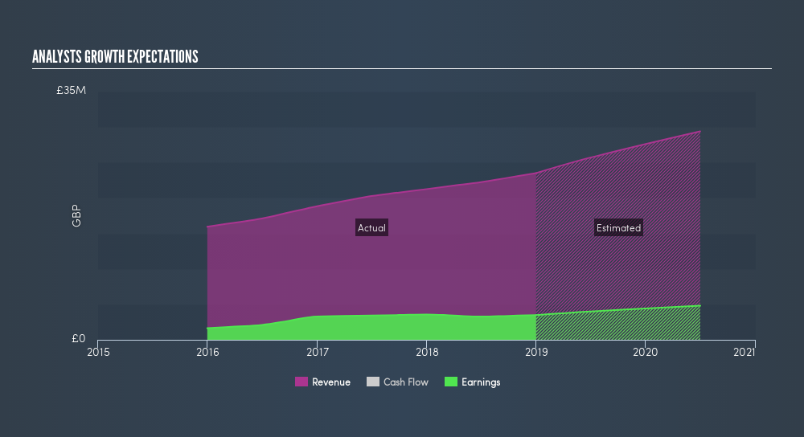

Figure Tristel PLC Past and future earnings 28 March 2019. (AIM)

Tristel PLC’s operating cash flow is expected to be increase in future by 73% and this will be going to effect on impressive return on equity of 21% during the upcoming years. According to the shareholders and brokers, Tristel manage its cost very well against their short-term liabilities because of which it is financial stable. Hence, in future also they will be able to manage their short-term upcoming liabilities. This has been explained by the graph shown below. (st, simply wall st, 2019)

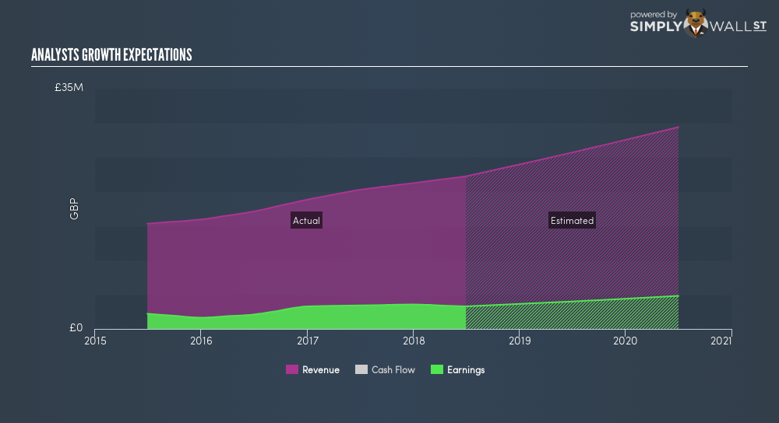

Figure Analyst Growth expectations

## 7.2 P/E RATIO analysis

Tristel PLC trading with the 32x P/E ratio, which is recorded very low than the average industrial norms of 33.6x.

|  |  |
| --- | --- |
| Tristel PLC | 2014 2015 2016 2017 2018 |
| P/E Ratio | 24.77 18.57 21.36 23.64 41.99 |

Table P/E ratio

The analysts examine that the P/E ratio is increasing since last five years in which the value was 24.77 in 2014 and that has been increased rapidly to 41.99 in 2018. As the PE ratio is currently increasing, in 2017 the recorded figure was 23.64, however, in the 2018 it rose to 41.99 which is the huge growth of PE. Because of the fluctuation in the share price from last few years. Tristel is now trending in stock market as the share price is low but shareholders invest in it as the part of their investments. This investment is suggested by analysts according to the P/E ratio as well as other factors discussed above.

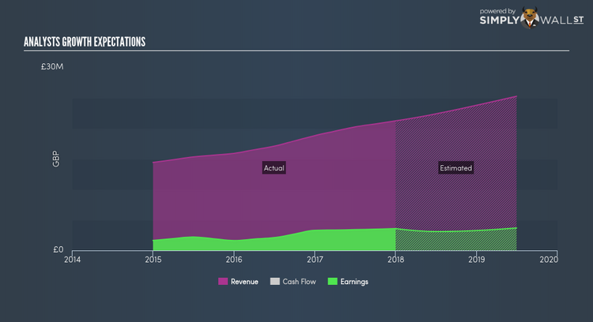

Table analyst growth expectation (st, simply wall st, 2019)

## 7.3 Market to Book Ratio

According to the annual report 2018, the market to book value is calculated as follows:

Total assets: 22.54 m GBP

Total Liabilities: 4.12 m GBP

Book Value per shareholders’ equity: 22.54 – 4.12 = 18.42 (Bloomberg, 2019)

Market Value = outstanding shares * current share price

= 44.46 * 286.00

= 12,751.56 m GBP

Market to book ratio which is also known as price to book ratio and used to examine the company’s current market value relative to its book value. In other words, this ratio basically gives the comparison between the net assets and the sales price of its stock. (CFI, 2015)

# Bibliography

abcam. (2019, March 30). *abcam*. Retrieved from abcam: https://www.abcam.com/

Abcam PLC. (2019, March 31). *abcam*. Retrieved from abcam: https://www.abcam.com/content/about-us

Abcam PLC. (2019, March 31). *Abcam Annual report*. Retrieved from Abcam: https://www.abcamplc.com/investors/annual-report/

Bloomberg. (2019, April 1). *Bloomberg*. Retrieved from Bloomberg: https://www.bloomberg.com/quote/TSTL:LN

BOYTE-WHITE, C. (2018, May 22). *Investopedia*. Retrieved from Investopedia: https://www.investopedia.com/ask/answers/121814/what-good-gearing-ratio.asp

CFI. (2015). *CFI*. Retrieved from CFI: https://corporatefinanceinstitute.com/resources/knowledge/valuation/market-to-book-ratio-price-book/

CSI Market. (2019, March 31). *CSI Market*. Retrieved from CSI Market: https://csimarket.com/Industry/industry_Financial_Strength_Ratios.php?s=800&hist=5

Hill, R. (2019, March 31). *Liquidity Ratio: Definition, calculations and analysis.* Retrieved from Study.com: https://study.com/academy/lesson/liquidity-ratio-definition-calculation-analysis.html

*Insider Media Limited*. (2019, March 31). Retrieved from https://www.insidermedia.com/insider/central-and-east/tristel-snaps-up-european-distributor

JASON WINTERS, K. J. (2019, January 10). *Plante moran*. Retrieved from Plante moran: https://www.plantemoran.com/explore-our-thinking/insight/2016/02/improving-operating-margins-four-principles-you-need-to-know

JEAN FOLGER. (2019, February 1). *Investopedia*. Retrieved from Investopedia: https://www.investopedia.com/ask/answers/062714/what-are-main-differences-between-current-ratio-and-quick-ratio.asp

Kearns, L. (2017, December 15). *Yahoo Finance*. Retrieved from Yahoo Finance: https://finance.yahoo.com/news/tristel-plc-lon-tstl-continue-114510788.html

MURPHY, C. B. (2019, February 28). *Investopedia*. Retrieved from Investopedia: https://www.investopedia.com/ask/answers/041415/what-considered-healthy-operating-profit-margin.asp

st, S. w. (2018, July 13). *Simply wall st*. Retrieved from Simply wall st: https://simplywall.st/stocks/gb/healthcare/aim-tstl/tristel-shares/news/what-does-tristel-plcs-lontstl-pe-ratio-tell-you/

st, S. w. (2019, January 24). *simply wall st*. Retrieved from simply wall st: https://simplywall.st/stocks/gb/healthcare/aim-tstl/tristel-shares/news/an-examination-of-tristel-plc-lontstl/

st, S. w. (2019, March 7). *simply wall st*. Retrieved from simply wall st: https://simplywall.st/stocks/gb/healthcare/aim-tstl/tristel-shares/news/does-tristel-plcs-lontstl-pe-ratio-signal-a-buying-opportunity/

st, S. w. (2019, March 28). *Simply wall st*. Retrieved from Simply wall st: https://simplywall.st/stocks/gb/healthcare/aim-tstl/tristel-shares/news/when-should-you-buy-tristel-plc-lontstl/

Tara, K. (2019, March 31). *azcentral*. Retrieved from azcentral: https://yourbusiness.azcentral.com/increase-net-operating-income-increasing-sales-11977.html

*Tristel*. (2019, March 31). Retrieved from Tristel: http://www.tristel.com/investor-centre

Tristel. (2019, March 31). *Tristel*. Retrieved from Tristel: https://www.proactiveinvestors.co.uk/LON:TSTL/Tristel-Plc/rns/LSE20190225070004_13979538

Tristel PLC. (2016). *Tristel PLC Final results.* UK: Tristel PLC.

Tristel PLC. (2017). *Tristel Final Results.* UK: Tristel PLC.

Tristel PLC. (2019). *Half-Year report.* UK: Tristel PLC.

WILL KENTON. (2019, March 8). *Investopedia*. Retrieved from Investopedia: https://www.investopedia.com/terms/w/workingcapitalturnover.asp

Ychart. (2019, March 30). *YCHART*. Retrieved from YCHART: https://ycharts.com/glossary/terms/debt_equity_ratio